$ GIT CONFIG –GLOBAL USER.NAME “<Give Username>”
$ GIT CONFIG –GLOBAL USER.EMAIL “`<GiveEmailID>”
$ GIT CONFIG --GLOBAL –-LIST Gives the Configuration List
$ git clone https://github.com/SouvikShome/MyGIT-Learning.git

$ git status

starting fsmonitor-daemon in 'C:/Personal Learning/GIT/MyGIT-Learning'
On branch main

No commits yet

nothing to commit (create/copy files and use "git add" to track)

Note: We use the "git status" command to see if there are any changes
between the working directory, the staging area, our local repository,

$ echo "Test GIT Quick Start Demo" >> start.txt
$ echo "<Content of the file>" >> <file name>
Create File in a location

$ cat start.txt
Cat command can be used to see the content of any file

$ git status
On branch main

No commits yet

Untracked files:
(use "git add <file>..." to include in what will be committed)
start.txt

nothing added to commit but untracked files present (use "git add" to track)

$ git add start.txt

Add the newly created file in staging area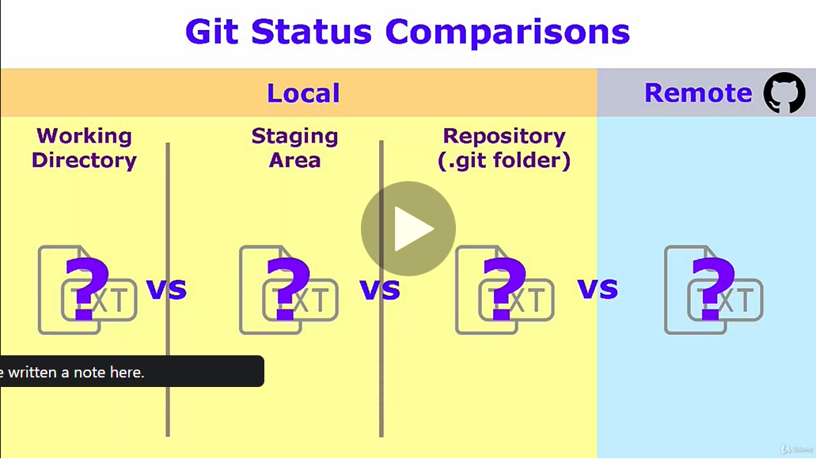

$ git status
On branch main

No commits yet

Changes to be committed:
(use "git rm --cached <file>..." to unstage)
new file: start.txt File is in staging area

Note:
"git status" tells us that I'm on the master branch.
The master branch is the default branch, by convention, for a Git repository.
The "git status" command also tells us master is "up-to-date with 'origin/master'.",
which refers to the master branch on the GitHub version of the repository;
We use the "git status" command to see if there are any changes
between the working directory, the staging area, our local repository,
and our remote repository. Now that we have our repository on our local system,

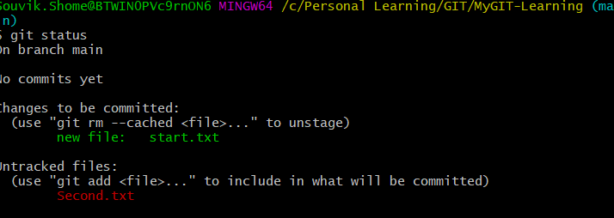

$ git commit -m "<Commit Message>"

Commit move the files to the local repo

TEXT EDITOR SETUP

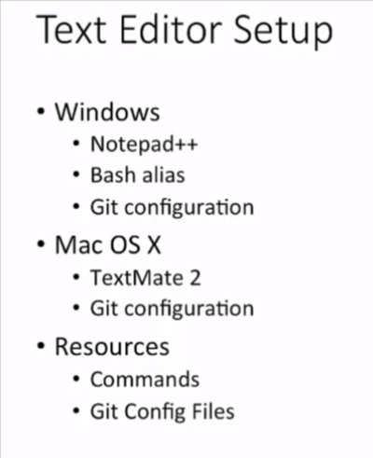

- Step-up notepad location in system variable
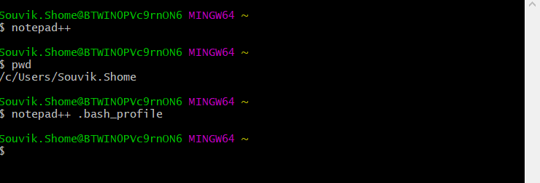

- To setup Notepad++ as the default editor within Git, let's launch Git Bash.
